1. PARSONAL DETAILES

Full Name :  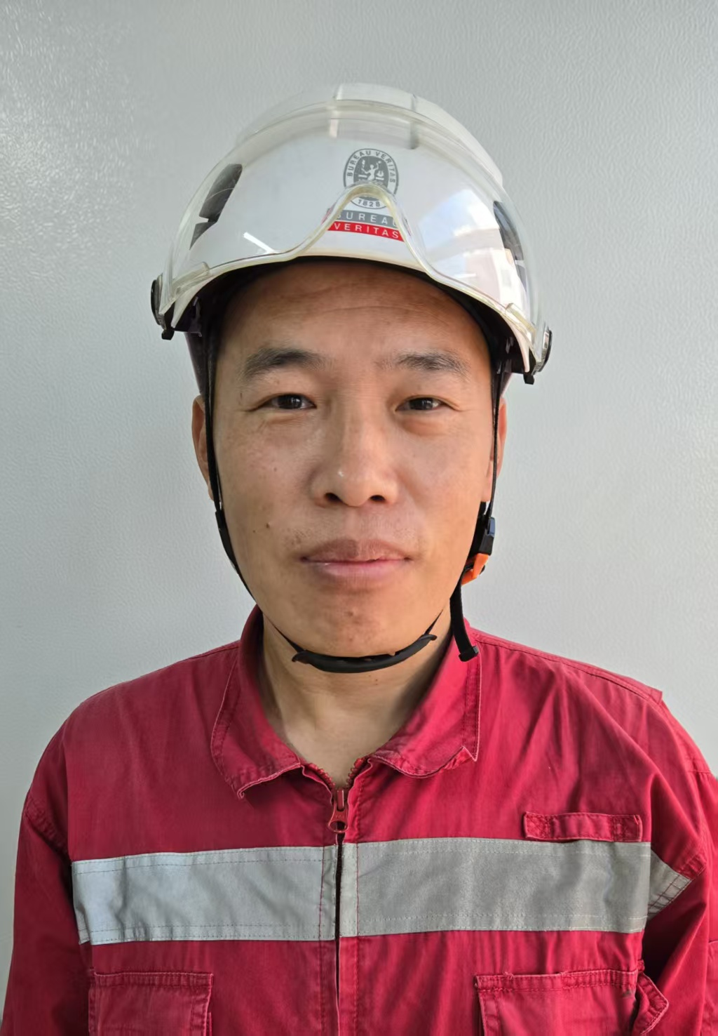 | Yin Zhang
Date of Birth : | 28th, Dec, 1977
Nationality : | P. R. China
Marital Status : | Married
Language : | Chinese, English

2. EDUCATION

Year |  |  | Education
2003 | - | 2006 | Dalian University of Technology, Majored in Technological Economy and Management
1996 | - | 2000 | Dalian Maritime University, Majored in Marine Engineering
 | -

3. QUALIFICATIONS

Month / Year  09/2022 | Description  Electrical Propulsion
09/2010 | BV NC Site Surveyor with SAY Certificate Level II
04/2009 | BV NC Site Surveyor with SAY Certificate Level I
12/2007 | Certificate of Third Engineer Officer
01/2006 | Master of Management
07/2000 | Bachelor of Engineering

4. TRAINING BEFORE AND AFTER JOINED WITH BV RELATED WITH CERTIFICATION

Training designation | Organized by | Date (start – end) | Duration (Months) | Training Course Description
OLAW Training | BV Shanghai | 10/10/2025 | 1 day | SOLAS Lifting appliances and Anchor winches
NC Annual Training 2025 | BV Shanghai | 16/01/2025 | 1 day | Cyber Resilient UR E26  Cases Study
Aluminum Training | BV Shanghai | 16/10/2024-  17/10/2024 | 2 days | Aluminum material training
SOLAS dangerous goods and VDGB training | BV Shanghai | 29/08/2024-  30/08/2024 | 2 days | SOLAS dangerous goods and VDGB training
PL Training | BV Shanghai | 12/03/2024-  14/03/2024 | 3 days | PL knowledge training for qualification acquisition
NC Thematic 2023 & Common 2023 | BV Shanghai | 11/01/2024 | 1 day | The training includes Case Study, Rules Updates, IACS and Flags Updates, HSE Updates etc.
IECEx Training | BV Shanghai | 24/11/2021-25/11/2021 | 2 days | Hazardous area and explosion proof equipment
NC Thematic 2021 & Common 2021 | BV Shanghai | Oct. 2021 | 1 months | The seminar training including new notations, PNC 0006, PAUT, IMO updates etc
NC2 Assembly Material Advanced | BV Shanghai | 16/06/2021-17/06/2021 | 2 days | Classroom training for WPS approval, welding patrol survey etc.
NC Annual Refreshment Training | BV Shanghai | 07/01/2021 | 1 day | New Statutory Regulations , Case Study etc.
NC Thematic 2020 | BV Shanghai | 14/08/2020 | 1 day | Common & Thematic 2020 Training online Qualif-Marine
LNG as Fuel Training | BV Shanghai | 27/07/2020-28/07/2020 | 2 days | Online by Teams
NC Annual Training | BV Shanghai | 09/01/2020 | 1 day | Cases Study
NC Thematic 2019 | BV Shanghai | 24/09/2019 | 1 day | Common & Thematic 2019 Training online Qualif-Marine
NC3 Electrical Propulsion | BV Shanghai | 04/09/2019-  05/09/2019 | 2 days | Electrical Propulsion Theoretical Training in Shanghai
PSPC Practical Training | BV Shanghai | 13/11/2018-16/11/2018 | 4 days | PSPC Practical Training in Penglai Jinglu Shipyard
IHM Theoretical Training | BV Shanghai | 09/05/2018-  10/05/2018 | 2 days | IHM Theoretical Training
2018 M&O Training Seminar | BV Shanghai | 19/01/2018 | - | 2018 M&O Training Seminar
NC Thematic 2017 | BV Shanghai | 27/03/2017-  30/03/2017 | - | NC Plenary & Thematic Training
NC Thematic 2016 | BV Shanghai | 12/06/2016 | - | NC Plenary & Thematic Training
NC Thematic 2015 | BV Shanghai | 29/10/2015 | - | NC Plenary & Thematic Training
NC 9 PSPC | BV Shanghai | 04/02/2015-06/02/2015 | 3 days | PSPC Theoretical Training
NC Thematic 2014 | BV Shanghai | 15/08/2014 | - | NC Plenary & Thematic Training
AUT Tutored Practical Training | BV Qingdao | 01/12/2011-06/03/2012 | 3 months | NC4 AUT Survey
NC4 AUT Training | BV Shanghai | 13/03/2011-15/03/2011 | 3 days | NC4 AUT Survey
Tutored Practical Training | BV Qingdao | 02/11/2009-03/02/2010 | 3 months | NC2,NC3,NC5,NC6 Surveys  Project Management
BV NC Surveyor Advanced Theoretical Training | BV Shanghai | 26/10/2009-31/10/2009 | 1 week | NC2, NC3, NC5, NC6  Project Management
NC Survey on Job Fellowship Training | BV Qingdao | 17/11/2008-18/02/2009 | 3 months | NC Class / Statutory Surveys
BV NC Surveyor Theoretical Training | BV Shanghai | 03/11/2008-14/11/2008 | 2 weeks | PNC06, PNC16, Class and Statutory Surveys, Rules, NDT, NC Documentation etc.
BV NC New Enrollee Basic Training | BV Shanghai | 06/10/2008-10/10/2008 | 1 week | Code of Ethics,  PNC 16-New Building Surveys, VeriSTAR New Building

5. WORK EXPERIENCE BEFORE AND AFTER JOINED WITH BV

Period : | 06/10/2008 to present
Position : | NC Surveyor of Bureau Veritas
Job Description : | New Construction Survey

Period : | 01/10/2006 – 01/09/2008
Position : | Assistant of Sea Trial Department in Qingdao Hyundai Shipyard
Job Description : | - Assisting the commissioning work of machinery  - Applying for class and owner inspection of machinery  - Attending sea trial of ships

Period : | 01/09/2000 – 01/07/2003
Position : | Third Engineer in Dalian Ocean Shipping Company
Job Description : | - Managing and maintaining main engine and auxiliary engines  - Keeping watch in engine room and ECR

Period : | dd mm year - dd mm year
Position :
Job Description :

6. DETAIL EXPERIENCE ON NC SURVEYS IN BUREAU VERITAS :

Type of experience | Ship name | Reg. No. | Ship type | Shipyard | Period | Surveyor or P.L.
Hull | CHANG SHUN II | 14418Y | Bulk Carrier  57K | Dalian COSCO | 14/10/2008 – 05/12/2008 | Surveyor
Hull | JIN ZHOU HAI | 14419A | Bulk Carrier  57K | Dalian COSCO | 14/10/2008 – 05/12/2008 | Surveyor
Hull | PU LAN HAI | 14420B | Bulk Carrier  57K | Dalian COSCO | 14/10/2008 – 05/12/2008 | Surveyor
Hull | CHANG SHAN HAI | 14421C | Bulk Carrier  57K | Dalian COSCO | 14/10/2008 – 05/12/2008 | Surveyor
Hull | INGRID C | 13451X | Bulk Carrier  57K | Dalian COSCO | 14/10/2008 – 05/12/2008 | Surveyor
Hull+ Mach.+ Elec.+ Statutory Survey No.1 | BELUGA NATION | 10236D | General Cargo (Container) | Qingdao  Heshun | 08/12/2008 – 20/03/2009 | Surveyor
Hull+ Mach.+ Elec.+ Statutory Survey No.1 | BBC NITEROI | 12389T | General Cargo (Container) | Qingdao  Heshun | 08/12/2008 – 03/07/2009 | Surveyor
Hull | BELUGA NOTION | 12390U | General Cargo (Container) | Qingdao  Heshun | 08/12/2008 – 15/12/2009 | Surveyor
Hull | BELUGA NOVATION | 12391V | General Cargo (Container) | Qingdao  Heshun | 08/12/2008 – 17/06/2010 | Surveyor
Hull+ Mach.+ Elec.+ Statutory Survey No.1 | BELUGA NOTIFICA-TION | 12392W | General Cargo (Container) | Qingdao  Heshun | 08/12/2008  – 02/12/2010 | Surveyor
Hull+ Mach.+ Elec.+ Statutory Survey No.1 | ALMAHROO-SAH | 12127J | Product Oil Tanker  7280T | Qingdao  Heshun | 08/12/2008 – 15/05/2009 | Surveyor
Hull+ Mach.+ Elec.+ Statutory Survey No.1 | ANUKET CORAL | 11805J | Product Oil Tanker  7280T | Qingdao  Heshun | 08/12/2008 – 18/01/2010 | Surveyor
Hull+ Mach.+ Elec.+ Statutory Survey No.1 | ALMAHBOO-BAH | 12128K | Product Oil Tanker  7280T | Qingdao  Heshun | 08/12/2008  –  27/07/2010 | Surveyor
Hull+ Mach.+ Elec. | ANUKET PEARL | 11806K | Product Oil Tanker  7280T | Qingdao  Heshun | 17/12/2008  – 16/09/2010 | Surveyor
Hull+ Mach.+ Elec. | BELUGA NOTATION | 12393X | General Cargo (Container) | Qingdao  Heshun | 08/12/2008  –02/04/2011 | Surveyor
Hull+ Piping+  Mach.+ Elec.+ AUT+ Statutory Survey No.1 | JURUTY | 12808Y | Bulk Carrier  75K | Penglai  Jinglu | 06/04/2011  –  17/10/2011 | D.P.L. Surveyor
Hull+ Piping+  Mach.+ Elec.+ AUT+ Statutory Survey No.1 | THISSEAS | 13315A | Bulk Carrier  75K | Penglai  Jinglu | 18/10/2011  – 04/04/2012 | D.P.L. Surveyor
Hull+ Piping+  Mach.+ Elec.+ AUT+ Statutory Survey No.1 | HERCULES | 21694H | Bulk Carrier  75K | Penglai  Jinglu | 05/04/2012-  03/04/2013 | D.P.L. Surveyor
Hull+ Piping+  Mach.+ Elec.+ AUT+ Statutory Survey No.1 | LEOPOLD LD | 17881N | Bulk Carrier  180K | Tianjin Xingang | 07/04/2013-19/03/2014 | Surveyor
Hull+ Piping+  Mach.+ Elec.+ AUT+ Statutory Survey No.1 | LA GUIMORAIS | 17878K | Bulk Carrier  40K | Tianjin Xingang | 07/04/2013-11/04/2014 | Surveyor
Hull+ Piping+  Mach.+ Elec.+ AUT+ Statutory Survey No.1 | LA RICHARDAIS | 17880M | Bulk Carrier  40K | Tianjin Xingang | 07/04/2013-18/03/2015 | Surveyor
Piping+  Mach.+ Elec.+ AUT+ Statutory Survey No.1 | MENELAOS | 26569G | Bulk Carrier  64K | Penglai Jinglu | 19/03/2015-20/08/2015 | Surveyor
Hull+ Piping+  Mach.+ Elec.+ AUT+ Statutory Survey No.1 | LEONIDAS | 26697V | Bulk Carrier  64K | Penglai Jinglu | 19/03/2015-  10/01/2017 | D.P.L. Surveyor
Hull+ Piping+  Mach.+ Elec.+ AUT+ Statutory Survey No.1 | PETROBRAS 67 / 70 | 26425A  26428D | FPSO  270K | COOEC Qingdao | 11/01/2017-  03/08/2018 | Surveyor
Hull+ Piping+  Mach.+ Elec.+ AUT+ Statutory Survey No.1 | KASTOR | 30702Y | Bulk Carrier  81K | Penglai  Jinglu | 06/08/2018-  10/01/2020 | D.P.L. Surveyor
Hull+ Piping+  Mach.+ Elec.+ AUT+ Statutory Survey No.1 | HAI YANG SHI YOU 119 | 30199C | FPSO  150K | COOEC  Qingdao | 13/01/2020  -  15/05/2020 | Surveyor
Hull | CMA CGM PATAGONIACMA CGM KIMBERLEY | 37279X  37899W | Container Ship  15K TEU | DSSC  Yantai | 18/05/2020  -  01/07/2020 | Surveyor
Hull+ Piping+  Mach.+ Elec.+ AUT+ Statutory Survey No.1 | LAS PALMAS | 39055D | Bulk Carrier | Penglai Jinglu | 02/07/2020  -  04/11/2021 | D.P.L. Surveyor
Hull+ Piping+  Mach.+ Elec.+ AUT+ Statutory Survey No.1 | FPSO SEPETIBA | 37069U | FPSO | BOMESC  Tianjin | 05/11/2021 - 25/11/2022 | Surveyor
Hull+ Piping+  Mach.+ Elec.+ AUT+ Statutory Survey No.1 | PRESIDENT JQ ADAMS | 41504Q | Container Ship  5500TEU | CSSC Qingdao Beihai | 28/11/2022  -  01/02/2024 | Surveyor
Hull+ Piping+  Mach.+ Elec.+ AUT+ Statutory Survey No.1 | PRESIDENT MONROE | 41508U | Container Ship  5500TEU | CSSC Qingdao Beihai | 15/12/2022  -  13/09/2024 | P.L. Surveyor
Hull+ Piping+  Mach.+ Elec.+ AUT+ Statutory Survey No.1 | CMA CGM OUVEA | 41512Y | Container Ship  5500TEU | CSSC Qingdao Beihai | 20/07/2023  -  Till now | P.L. Surveyor
Hull+ Piping+  Mach.+ Elec.+ AUT+ Statutory Survey No.1 | CMA CGM TIGA | 41513A | Container Ship  5500TEU | CSSC Qingdao Beihai | 17/11/2023  -  03/04/2025 | Surveyor
Hull+ Piping+  Mach.+ Elec.+ AUT | SEA PELICAN I | 44734B | Light Ship | Qingdao Special Boat Technology Pte Ltd. | 18/10/2023-  30/08/2024 | Surveyor
Hull+ Piping+  Mach.+ Elec.+ AUT | SEA PELICAN 2 | 44735C | Light Ship | Qingdao Special Boat Technology Pte Ltd. | 18/10/2023  -  10/01/2025 | Surveyor
Hull+ Piping+  Mach.+ Elec.+ AUT+ Statutory Survey No.1 | PRINCESS LEILI | 45024R | Light Ship | Qingdao Allheart Marine Co., Ltd. | 18/04/2024-  Till now | Surveyor
Hull+ Piping+  Mach.+ Elec. | FB51 | 49376W | Light Ship | Qingdao Special Boat Technology Pte Ltd. | 08/07/2025  -  30/01/2026 | P.L .  Surveyor
Hull+ Piping+  Mach.+ Elec.+ AUT+ Statutory Survey No.1 | STAR EMMA | 46095F | Bulk Carrier  82K | CMSI Qingdao Shipyard | 07/04/2025-  Till now | Surveyor
Hull+ Piping+  Mach.+ Elec.+ AUT+ Statutory Survey No.1 | STAR EVELINA | 46096G | 82K DWT Bulk Carrier | CMSI Qingdao Shipyard | 07/04/2025  -  22/05/2026 | D.P.L. Surveyor
Hull+ Piping+  Mach.+ Elec.+ AUT+ Statutory Survey No.1 | LIONESS C | 44744M | 82K DWT Bulk Carrier | CMSI Qingdao Shipyard | 07/04/2025  -  Till now | Surveyor
Hull+ Piping+  Mach.+ Elec.+ AUT+ Statutory Survey No.1 | FAETHON | 46665A | 82K DWT Bulk Carrier | CMSI Qingdao Shipyard | 07/04/2025  -  Till now | Surveyor

Hull+ Piping+  Mach.+ Elec.+ AUT+ Statutory Survey No.1 | STAR ARGYRO | 46099K | Bulk Carrier  82K | CMSI Qingdao Shipyard | 16/07/2025-  Till now | Surveyor

